COURSEWORK – EMFSS ST2187 – Business analytics, applied modelling and prediction

Student Number: 200693291

Table of Content

**The executive summary** 3

**Dashboard 1: Customers** 3

**Dashboard 2: Margin rate and shipping cost:** 4

**Dashboard 3:** 5

**Dashboard 4: US Market** 6

**Dashboard 5: EU market** 7

**Business proposals.** 8

**References:** 9

The executive summary

This coursework provides an analysis of the given e-commerce company in the period 2016-2021 years. In this analysis different approaches of data visualization like bar charts, pie charts, tree maps and etc. will be provided. The provided story demonstrates the main trends of the company development and weak spots. Also, some business proposals will be provided in the end of the report.

Based on the results of the research, we can observe the dynamics of growth in sales volumes and the market as a whole over the past 5 years. The company sells all over the world, most of the products are profitable. Some products have the highest profitability and sales volume, such as phones, copiers, chairs and bookcases. Negative profits in all markets are for merchandise in the table category. The largest market is the U.S. market. The largest customer segment is private consumers. Overall, each market is positively marginal, but looking within markets individually, there are countries that have negative marginal rates and negative profits. It is also worth noting that there are problems with high shipping costs and discount strategies.

Dashboard 1: Customers



This dashboard represents overall information about customers in different segments.

According to the Customer Map graph, the Us market is the hugest. Also, there are a lot of customers in Australia, India and China.

Prediction of customers and profit graph helps us to see the dynamic of profit and number customers through the years. Also, there is a forecast for the next 2 years. The tendency of growth in profit and consumers will be remain for the next 2 year in all segments. However there is a prediction of a small fall in profit for corporate segment in the begging of 2021, but after that the most significant increase.

Furthermore, The main key point is that there are most selling products are phones, copiers, bookcases and chairs. Also, the consumers segment has the quantitative advantage among others segments, which is illustrated on the Customers by segment graph.

Dashboard 2: Margin rate and shipping cost:



On this dashboard there are a discovery of margin rate and shipping cost.

The margin rate for the given data were calculated by the following formula : profit divided by sales.

On the graph «Margin rate by country» we can see that for the some countries the margin rate are negative, however for the most of the most of them it is positive. There are a negative margin rate for country in EMEA and APAC market like Kazakhstan, Mongolia and Turkey. This may cause by the fact that this market on the growth stage rate now.

« Avg. shipping cost & Avg. profit /Order Priority & Ship Mode» illustrates that all orders priority among ship mode equally affects the profit. Furthermore, the critical order priority cost the most. The interesting fact that the ship mode doesn’t influence the average shipping cost.

The most expensive in terms of shipping costs is APAC market across all segments. The most profitable in terms of shipping is EMEA and Canada markets. Also, the most expensive delivery costs related to the furniture category of goods, while the profit level is significantly lower when compared to the other categories. In addition, we can see that the table sub-category with the highest cost has the negative margin rate. Office suppliers goods have the lowest shipping cost and they are positively margin in general.

Dashboard 3:



This dashboard overviewed the discounts across all sub-categories.

The main insight of this widget : big discounts result in low profits.

The analysis of discounts will help understand whether big discounts for sub-category result in low profits.

Discounts for tables are the lowest in this group and the profit is the lowest too. All goods in sub-categories with the discount have the negative profit. Copiers and phones has the highest profit and they have a small discounts. Also, it is can be seen that discount and sales don't have strong correlation. We can suggest that discount affects profit, and increase in discount will lead to decrease in profit.

Dashboard 4: US Market

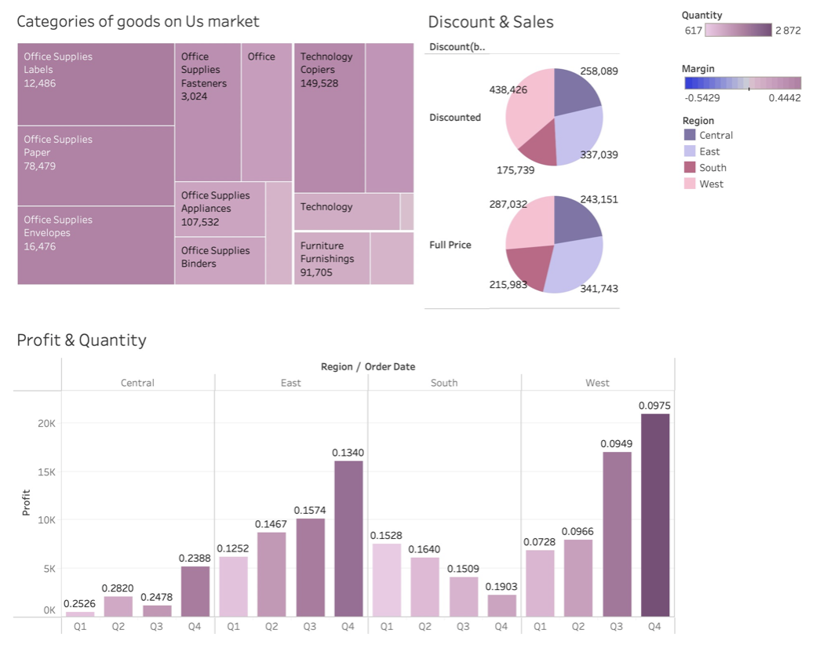

This dashboard establish the situation on the Us market as the largest one.

The tree map of goods, analysis of discounts and profit by regions are presented there.

So, according to the «Categories of goods on Us Market» we can see that the most marginal category is office supplies and the most marginal products are labels, paper, envelopes and copiers. Analysis of regions shows that in general 4th quartal are the most profitable and The west states consume more goods and more profitable than the others states.

It is an interesting fact that the souths states profits decreases while the quantity increases, that is against the main trend. However, it may cause by the fact that the average discounts are increases from 15% to 19%.

Dashboard 5: EU market

This dashboard illustrates the EU market trends and problems.

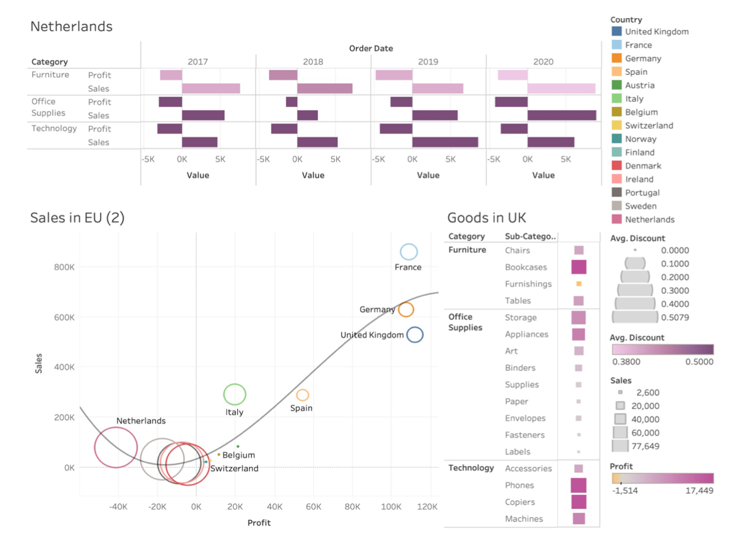

According to the scatter plot the most profitable countries are France, Germany and The UK Their average discount is about 10%. 7 countries have negative profit or close to 0 profit, the average discount in this countries is about 50%. The less profitable country is Netherlands. So, in further analyses we are going to look further to situations in The UK and Netherlands as the most profitable and the less profitable counties on EU market.

The UK market’s margin is about 20%.(Sales on EU market) There are only one non-profitable good on The UK market – Furnishing, however it’s sales is very small. The profitable goods sale better on The UK market. The most marginal category is Technology. (Goods in UK).

According to the Nitherland’s graph the key problem is a huge discount rate. We can see that all goods has a discount from 38% to 50%. No one has a positive profit through 4 years. However the number of sales increased in 2020 years in all categories, but profit remains the same.

Business proposals

According to analyses provided above, the e-commerce company has some problems with discount strategy and the ship problem and some goods are non-profitable at all.

At first, the company should reconsider discount policy, for example in the Netherlands the is a increasing trend in sales quantity, although the profit is still negative and the average discount is 50%, so the firm should decrease a discount to 25% at least. According to analyses of discount on The US and The UK market the best results goes with 10%- 15% discount and the increase in discount leads to decrease in sales.

Secondly, there are some problem with shipping system and it is better to reconsider it. For example, the furniture goods like tables has the highest shipping cost but the tables sub-category is not very profitable. This cost can be reduced by organizing a local storage for the most popular goods.

References:

<https://medium.com/@carsonzhou/earlier-this-semester-i-started-tableau-8cb2d2812228>

<https://penpath.com/resources/best-ecommerce-dashboards/>

<https://public.tableau.com/app/profile/vishal.malo/viz/BrazilianE-Commerce/BrazilianE-CommerceStory_1>